T

**2024 at Fair Haven Public Library**

Patrons made **10,595** visits to the library.

**6,459** items were circulated.

**60** reference transactions were made.

We borrowed **1,202** items through Interlibrary loan.

We loaned **3,382** items through Interlibrary loan.

Computers were used **47** times.

Wireless internet was used **730** times.

The library has **270** registered resident borrowers and **297** registered non-resident borrowers.

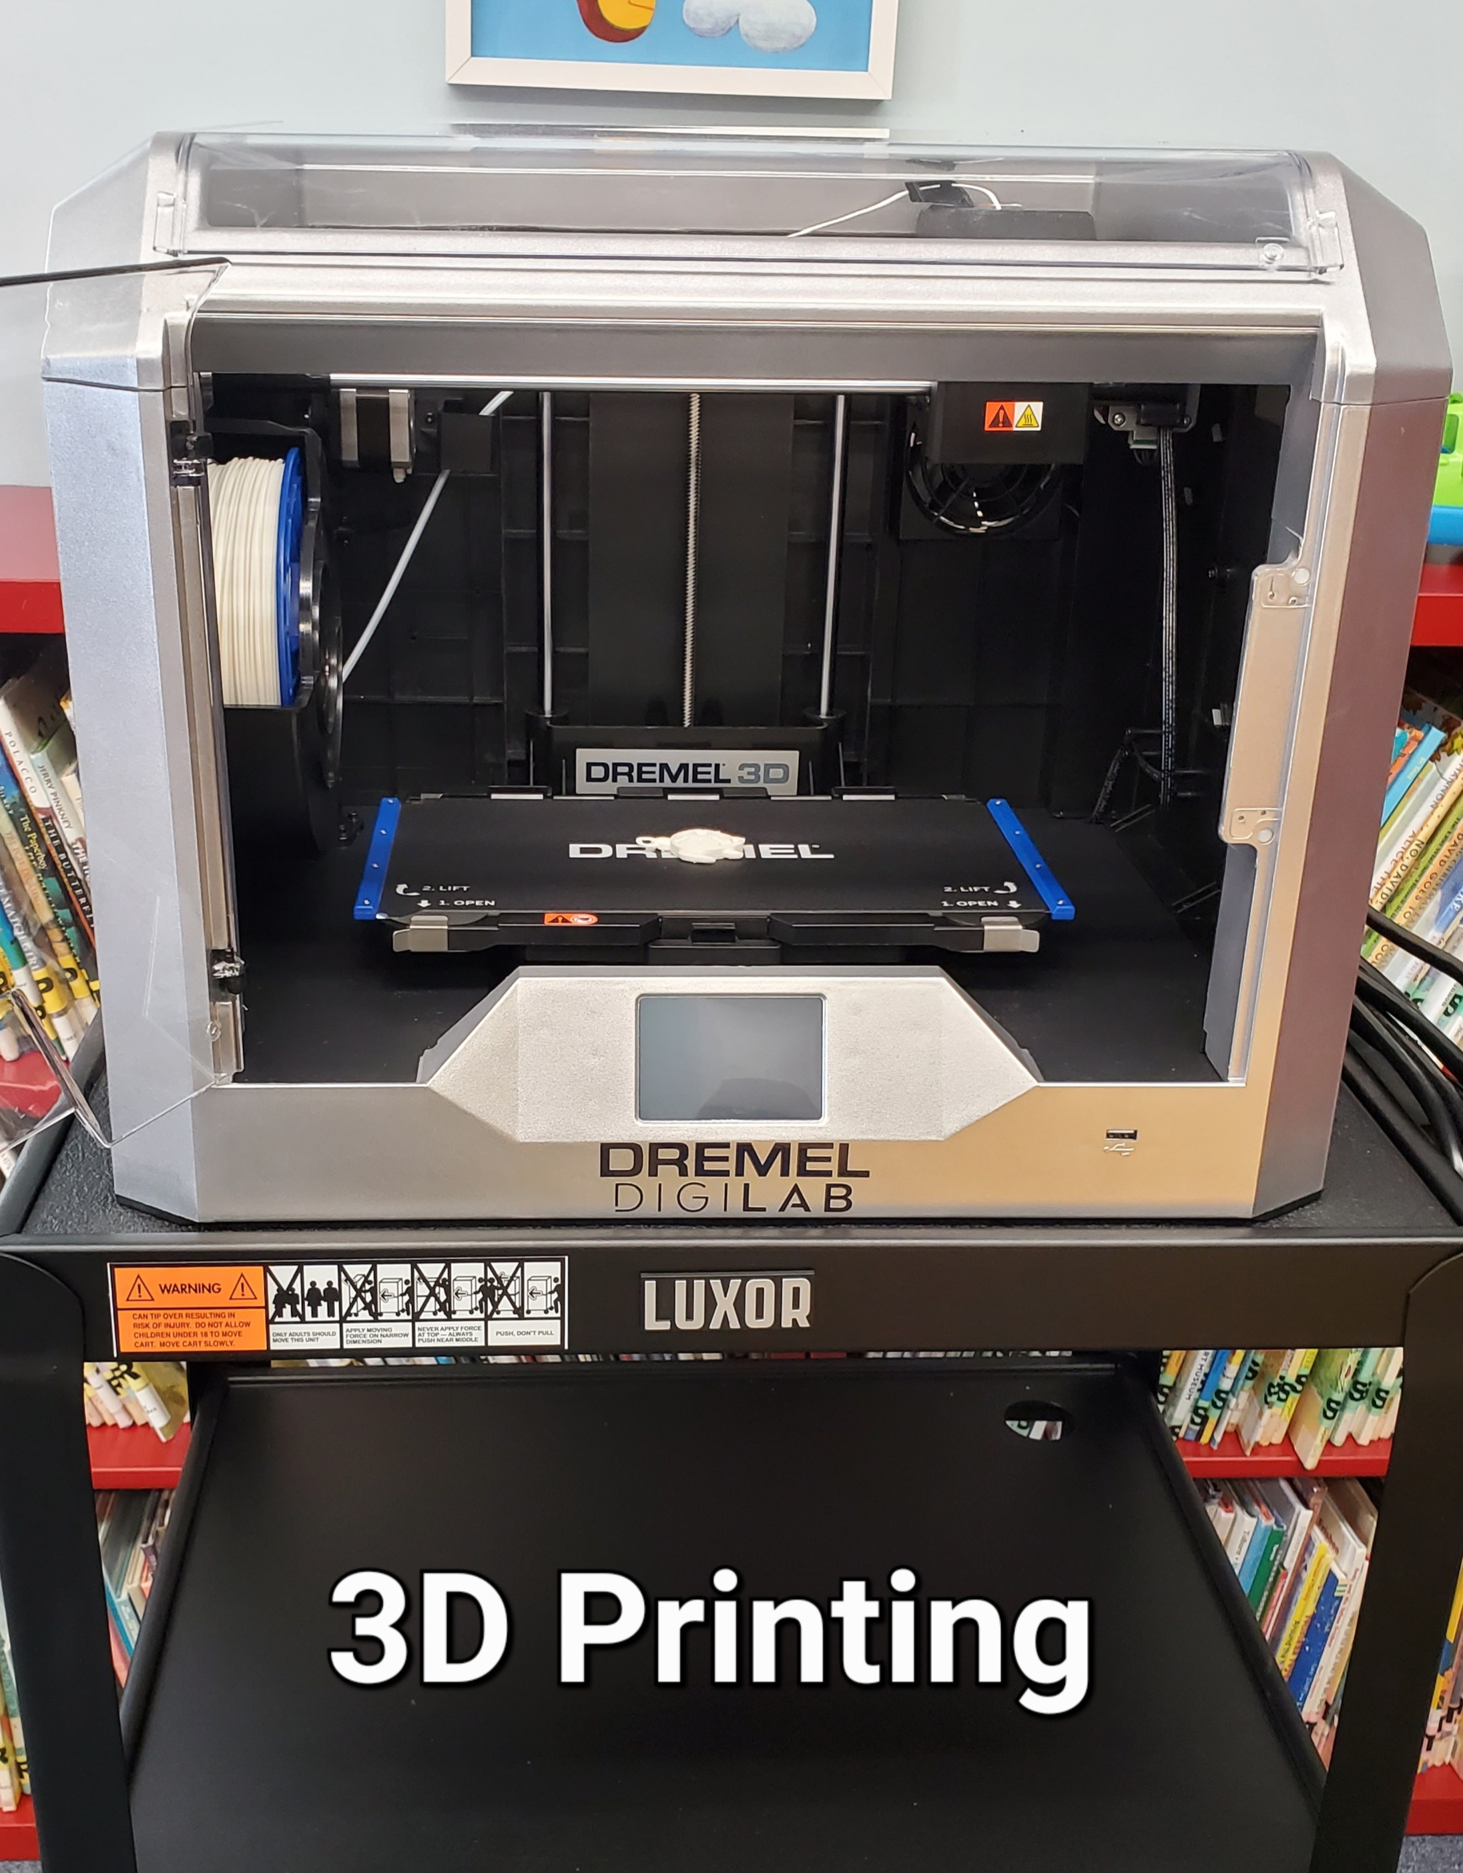 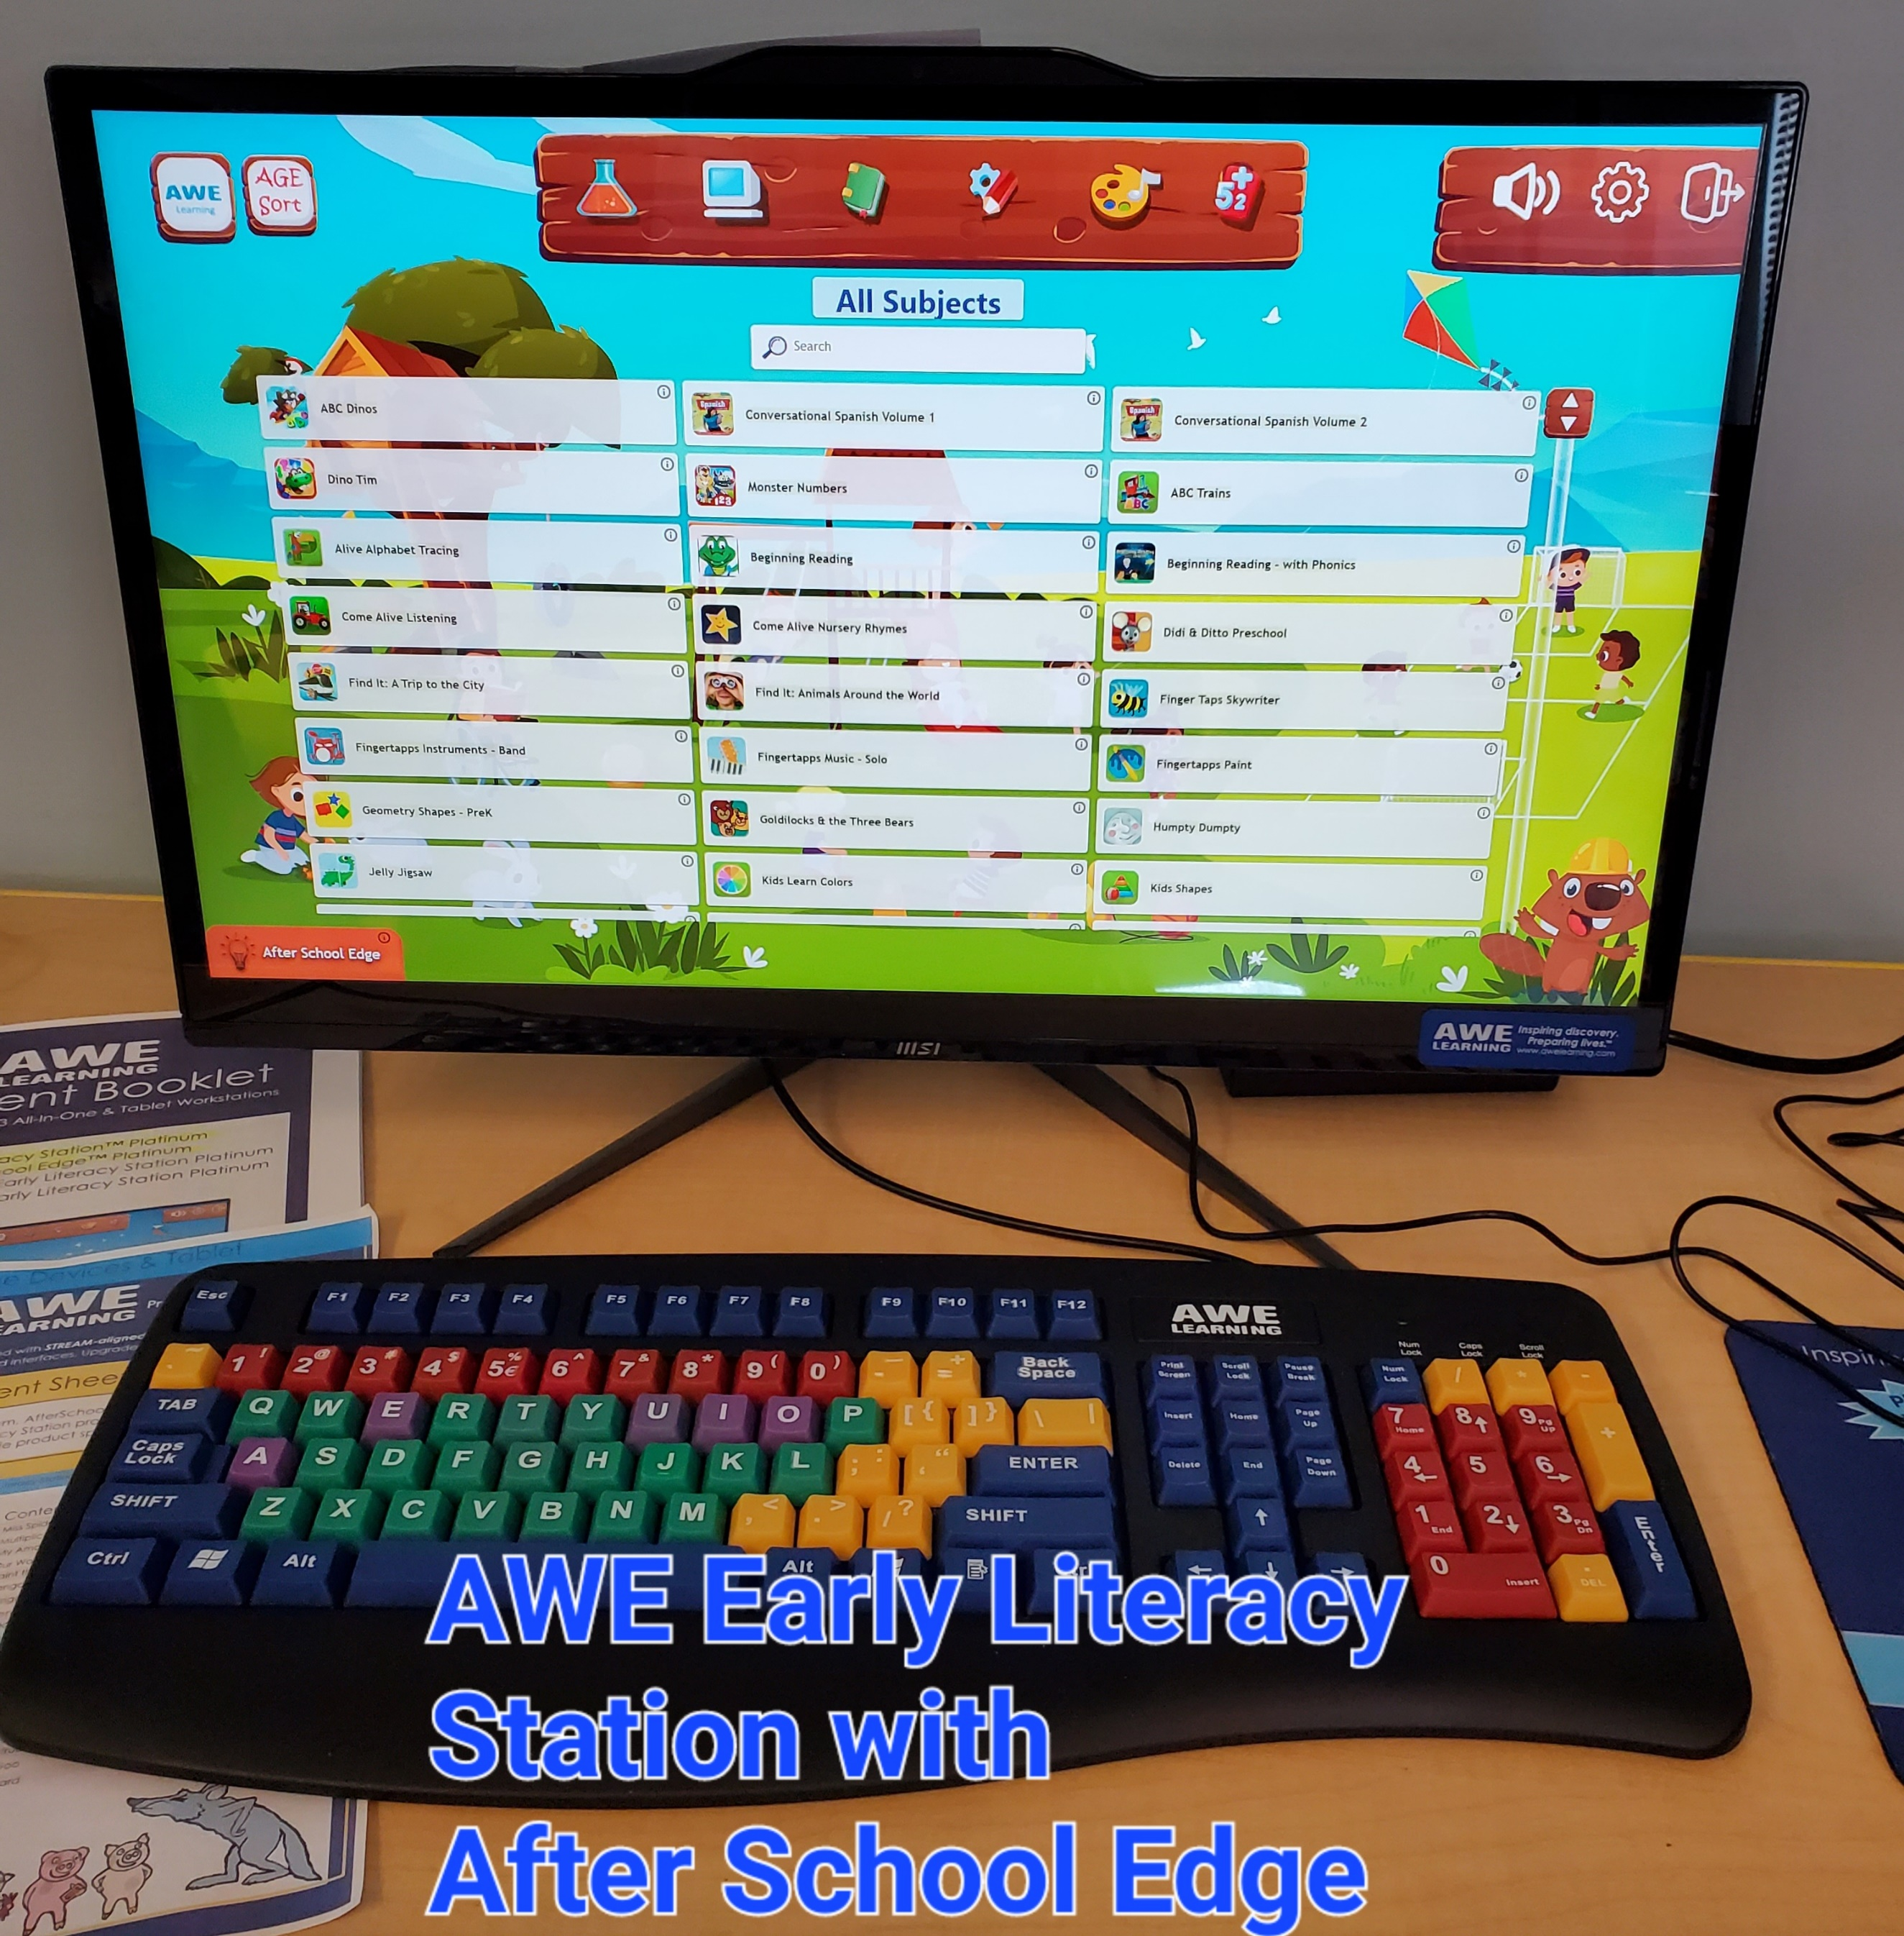

**723** adults and children attended **76** in-person programs in 2024. Programs offered included programs for adults, story hours, programs for homeschool families, G&G Animals and “Adventure Begins at your Library” NYS Summer Reading Program.

The library houses:

**13,371** books, **310** Audiobooks, and **762** DVDS we subscribe to **24** magazine publications.

**10** Volunteers provided **1092** hours of in person service to the library.

**\*Memorial Bench installed in front of Library**

**\* Cayuga County 4H STEM Programs held at the library.**

**\*Received Collection Development grant through FLLS to be used in 2025**

**\*Partnered with Cayuga Museum of History and Art for stem programs**

**\*Received grant funds from the Auer Family Foundation and purchased an AWE Early Literacy Station with Afterschool Edge for use by local youth.**

**\*Replaced 2 public computers.**

**\*Held Total Solar Eclipse Program.**

**\*Participated in RCCSD Back to School Carnival**

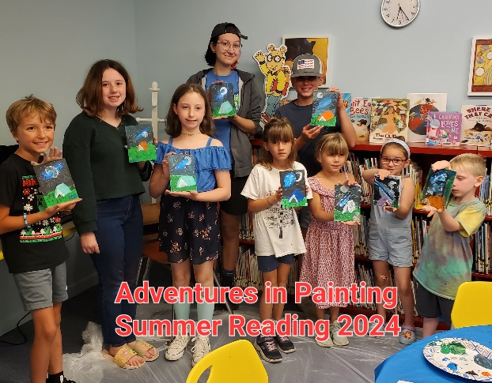

FAIR HAVEN PUBLIC LIBRARY

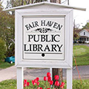

2024

ANNUAL REPORT

TO THE COMMUNITY

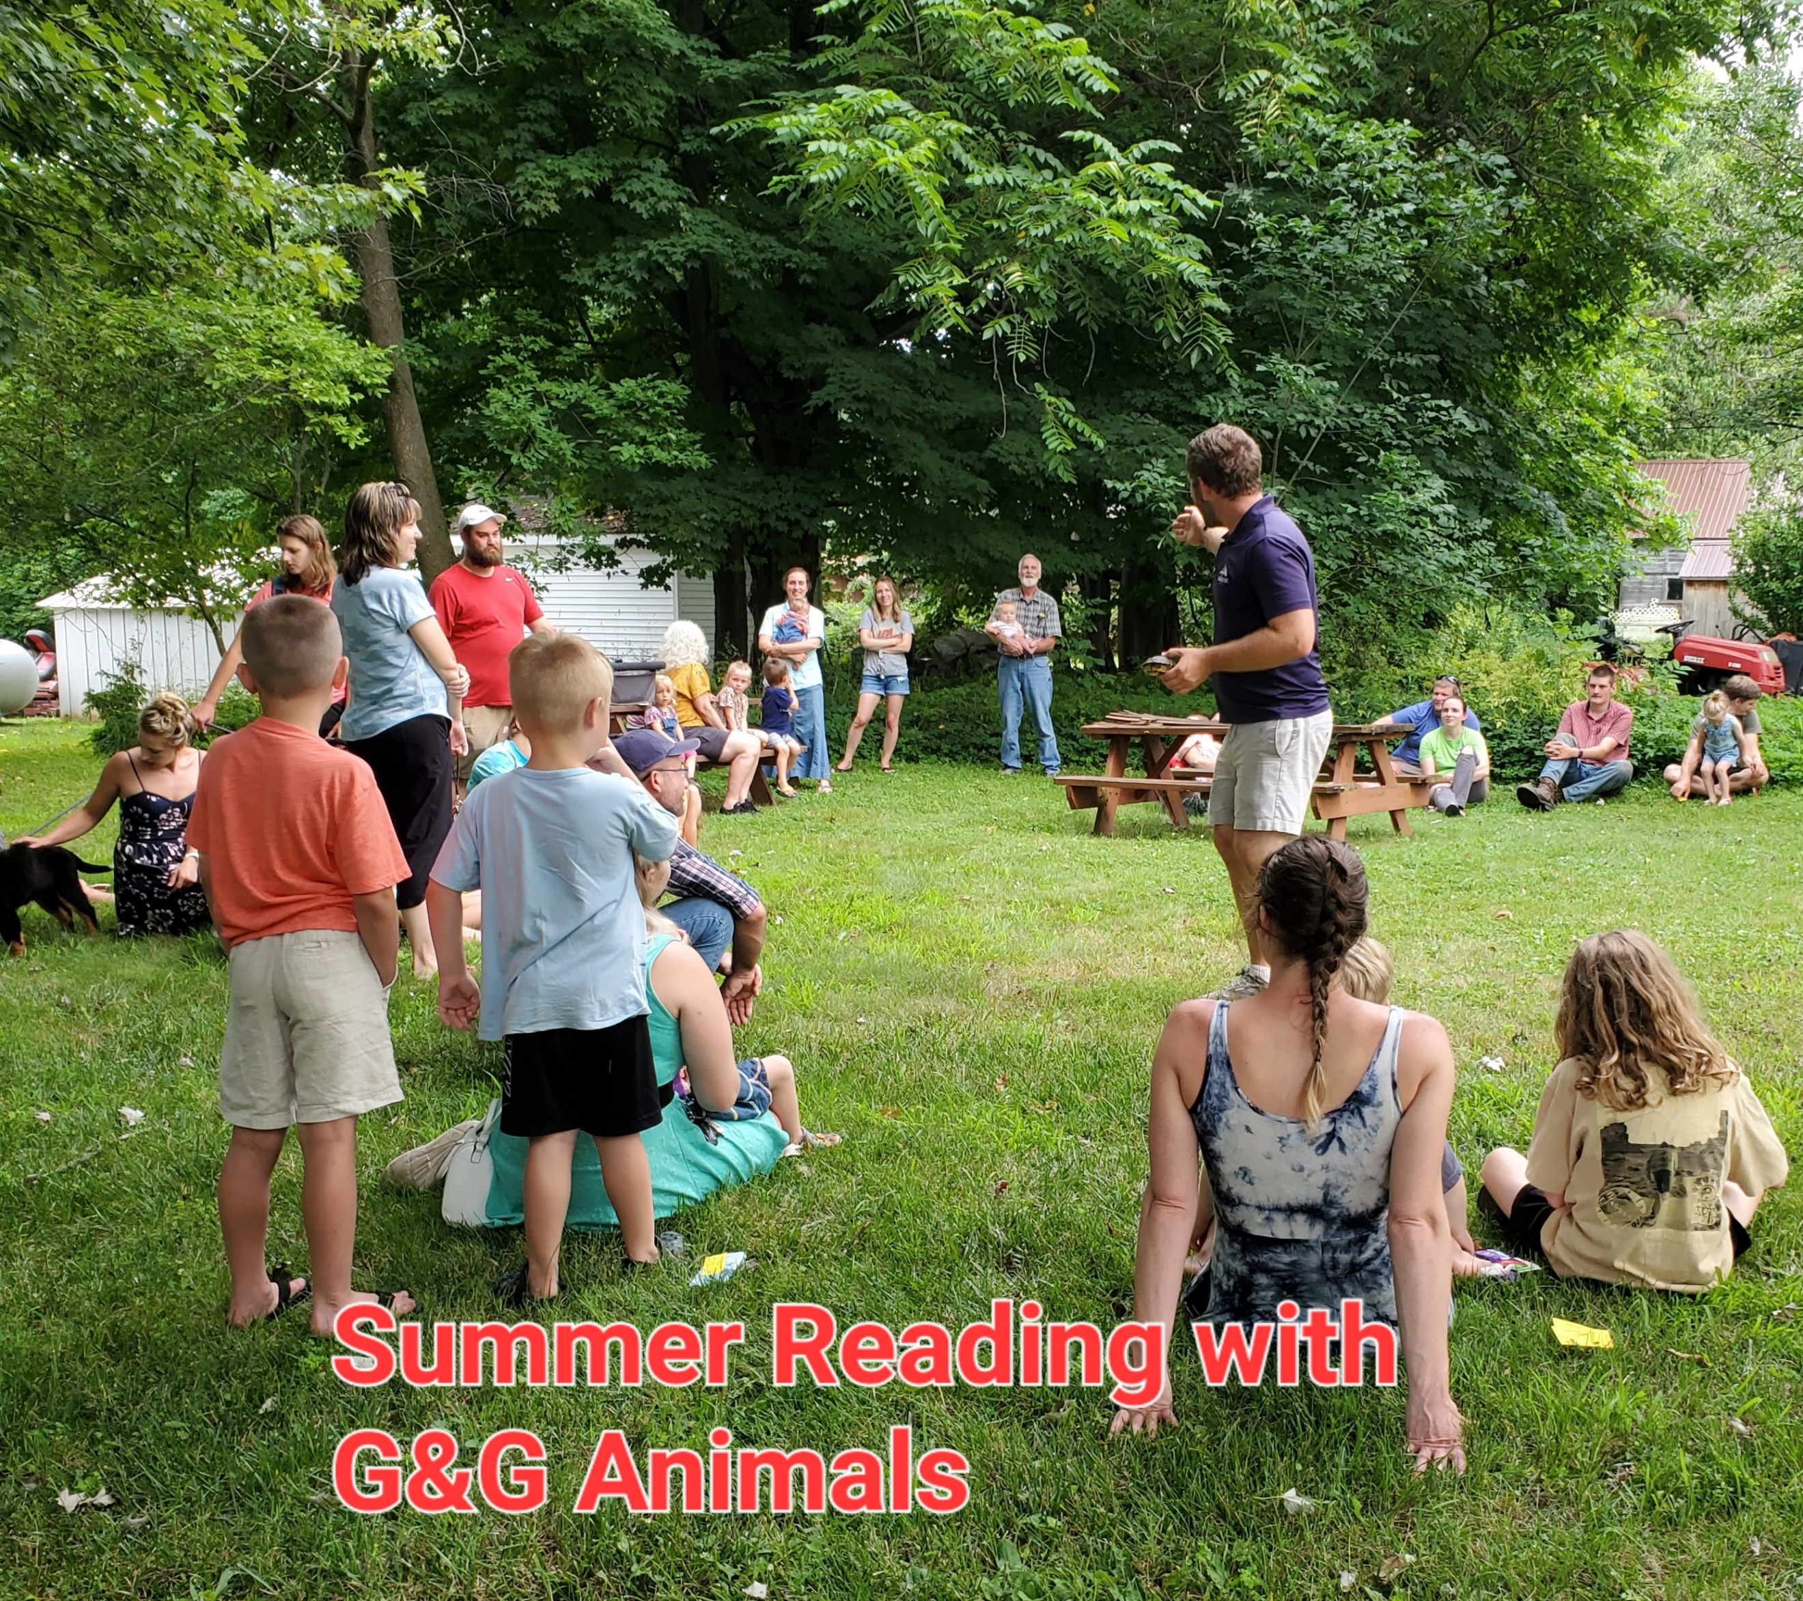

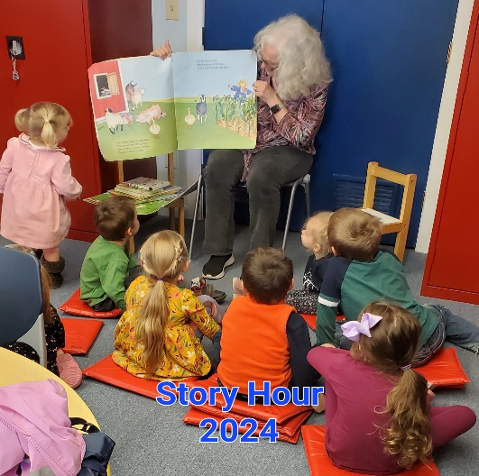

[**www.fairhavenlibrary.org**](http://www.fairhavenlibrary.org)

