T

**2023 at Fair Haven Public Library**

Patrons made **8,991** visits to the library.

**6,257** items were circulated.

**58** reference transactions were made.

We borrowed **885** items through Interlibrary loan.

We loaned **3,609** items through Interlibrary loan.

Computers were used **80** times.

Wireless internet was used **730** times.

**5,867** visits were made to our website.

The library has **257** registered resident borrowers and **276** registered non-resident borrowers.

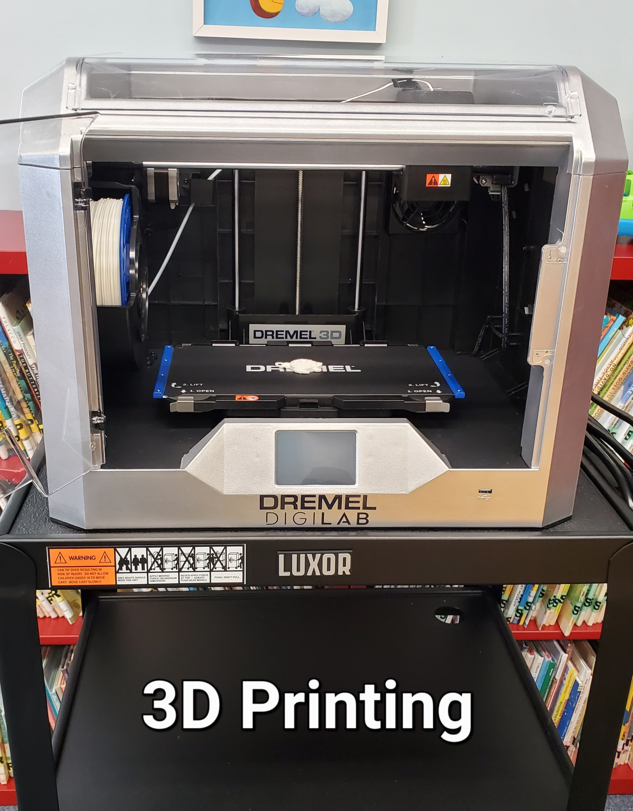

**630** adults and children attended **65** in-person programs in 2023. Programs offered included programs for adults, story hours, programs for homeschool families, Pirate Day with Captain Jack, and “All Together Now” NYS Summer Reading Program.

The library houses:

**13,035** books, **303** Audiobooks, and **739** DVDS we subscribe to **24** magazine publications.

**10** Volunteers provided **1092** hours of in person service to the library.

**\* Cayuga County 4H STEM Programs held at the library.**

**\*Received Collection Development grant through FLLS to be used in 2024**

**\*Participated in United Way of Cayuga County Annual Day of Caring.**

**\* Circulated Pass for The Children’s Museum of**

**Oswego, which was purchased with funds**

**from Savannah Bank N.A. of Fair Haven**

**\* Children’s Room ceiling painted.**

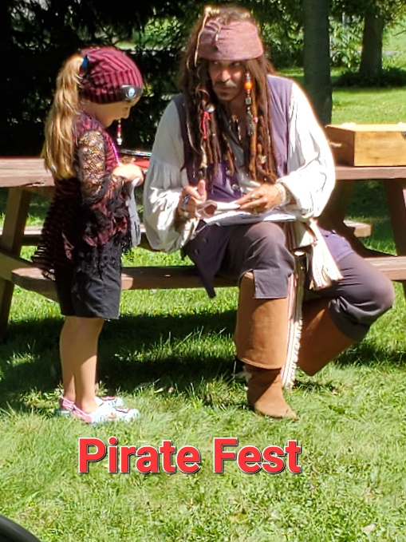

FAIR HAVEN PUBLIC LIBRARY

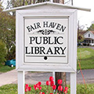

2023

ANNUAL REPORT

TO THE COMMUNITY

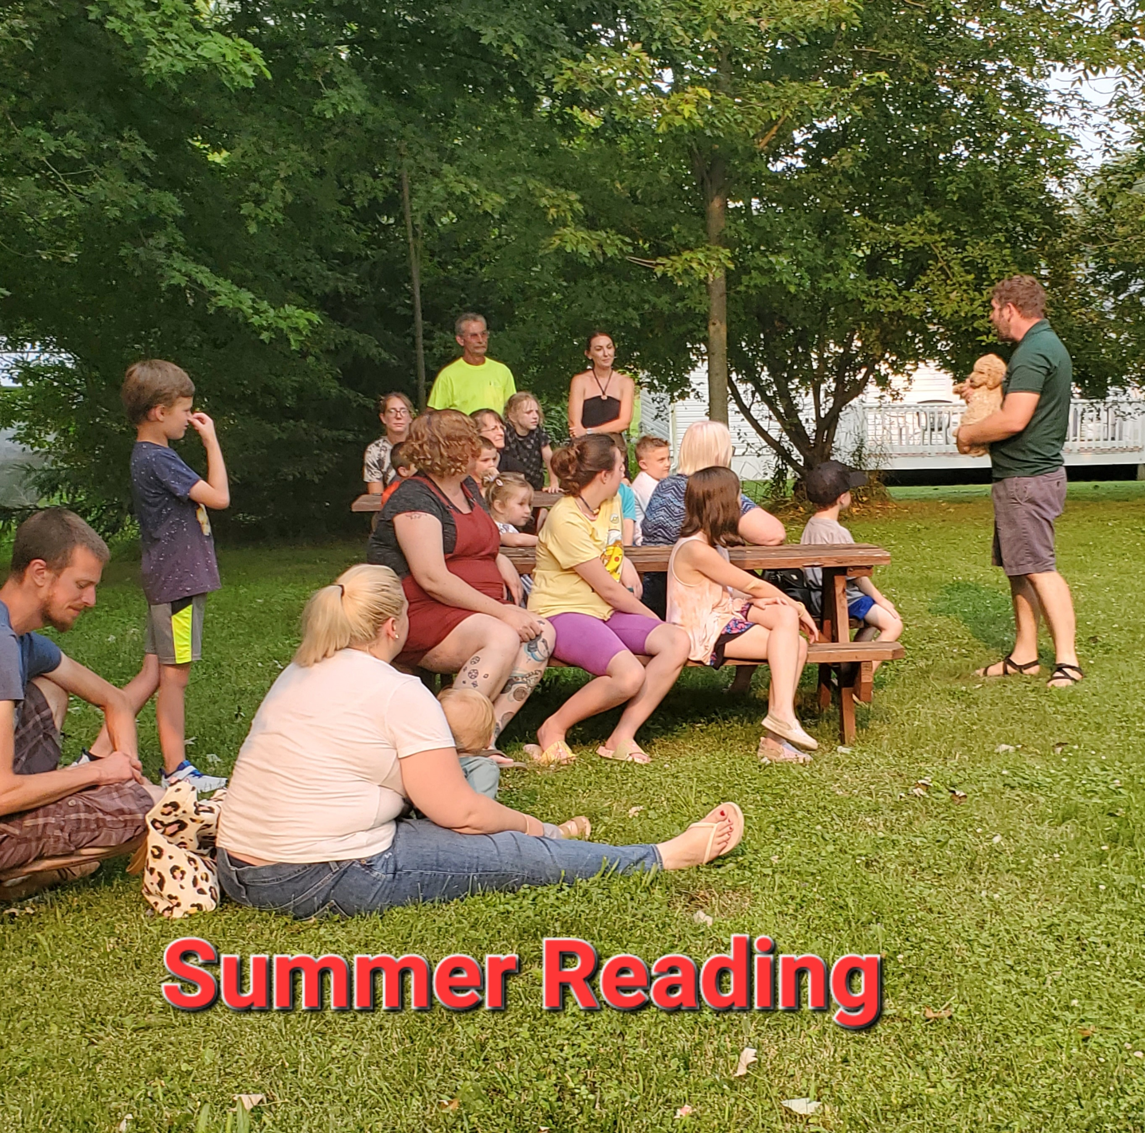

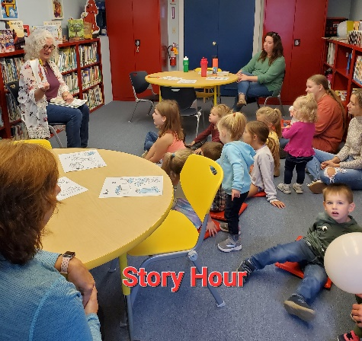

**www.fairhavenlibrary.org**

