T

**2022 at Fair Haven Public Library**

Patrons made **8,724** visits to the library.

**5,776** items were circulated.

**60** reference transactions were made.

We borrowed **943** items through Interlibrary loan.

We loaned **3,440** items through Interlibrary loan.

Computers were used **97** times.

Wireless internet was used **1,095** times.

**23,169** visits were made to our website.

The library has **281** registered resident borrowers and **300** registered non-resident borrowers.

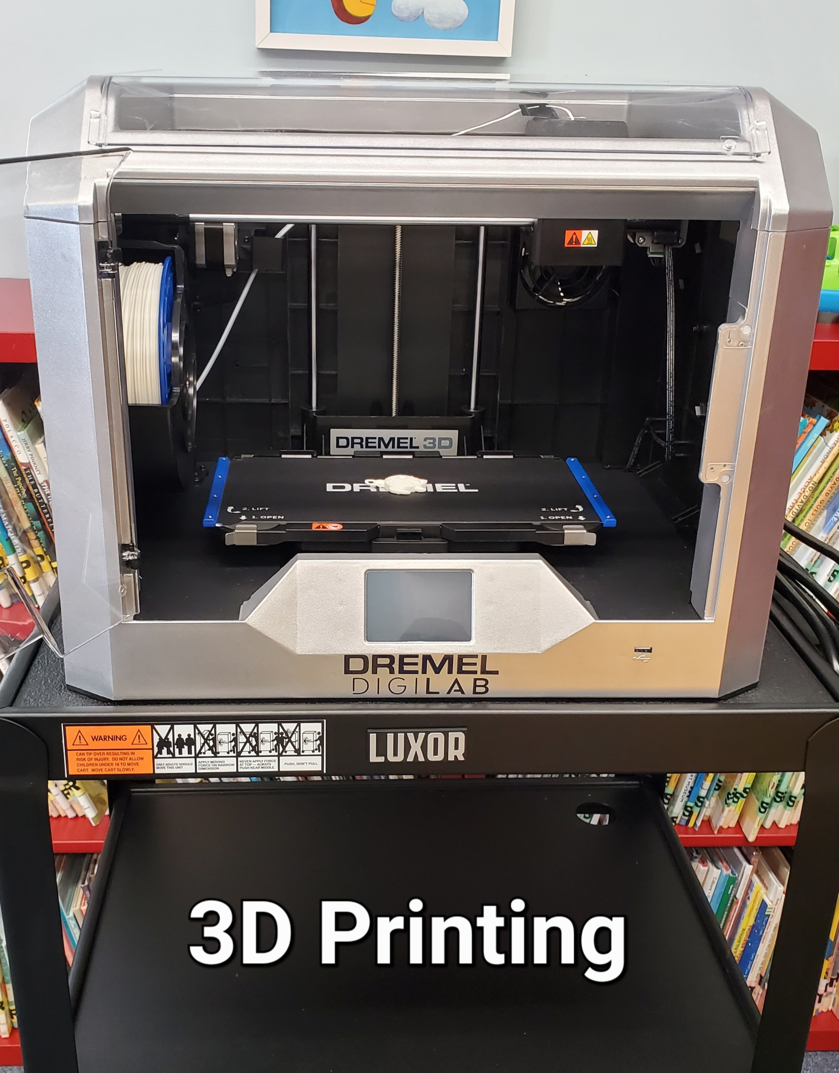

**427** adults and children attended **39** in-person programs in 2022 Programs offered include programs for adults, story hour, programs for homeschool families, Pirate Day with Captain Jack, and “Oceans of Possibilities” NYS Summer Reading Program.

The library houses:

**13,143** books, **297** Audiobooks, and **724** DVDS we subscribe to **24** magazine publications.

**12** Volunteers provided **1092** hours of in person service to the library.

**\*Received Special Legislative Grant for projects.**

**\* Cayuga County 4H STEM Programs held at the library.**

**\*Purchased 3D Printer for public use.**

**\*Received grant from Fair Haven/Red Creek Rotary for public performers.**

**\*Received Collection Development grant through FLLS to be used in 2023**

**\*Participated in United Way of Cayuga County Annual Day of Caring.**

**\*Purchased new all in one printer.**

**\*Participated in a grant to offer museum passes through FLLS and funded by the Myrtle Dee Nash Memorial fund of the Community Foundation of Tompkins County.**

**\*Windows were replaced.**

**\*Roof over Children’s Room replaced.**

**\*Replaced Router and increased bandwidth**

FAIR HAVEN PUBLIC LIBRARY

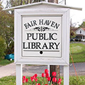

2022

ANNUAL REPORT

TO THE COMMUNITY

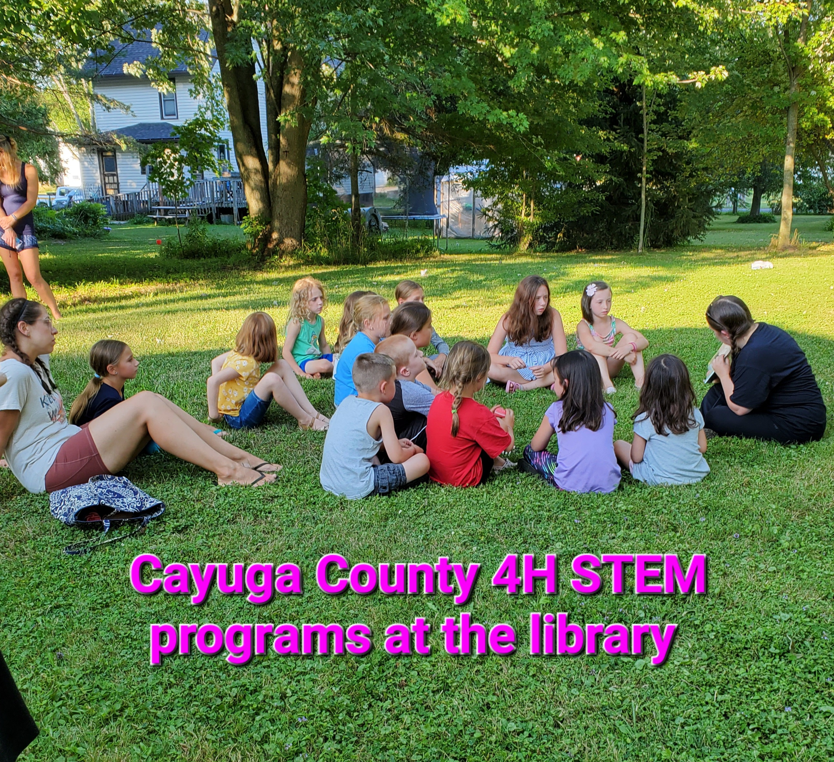

**www.fairhavenlibrary.org**



