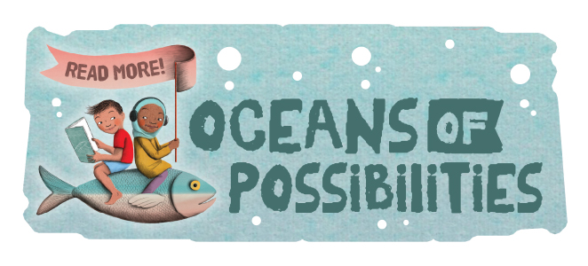
This summer we have an exciting program of events planned at the Fair Haven Public Library. With the theme being “Oceans of Possibilities”, you can expect activities that will include both books and marine mammals. Our summer reading program will begin on June 30, 2022 and conclude on August 8, 2022.
Beginning June 30 children, teens and adults may register for our “Oceans of Possibilities” summer reading program and may begin turning in minutes spent reading.
Each time you turn in minutes read you will receive a prize and you will also be entered into our Grand Prize drawing. Reading logs may be redeemed for prizes as frequently as you chose so keep reading!
In person programs are scheduled for the following days. Programs are free and open to the entire family.
Monday July 18 at 6:30 pm “Cap’n Dave’s Magic Treasure Hunt”
Monday July 25 at 6:30 pm Oceans of Possibilities: Books, Crafts, and Games
Monday August 1 at 6:30 pm Oceans of Possibilities: Books, Crafts, and Games
Monday August 8 at 6:30 pm “Captain HurriCains Underwater Adventure Magic Show”
August 8, 2022 Will be the conclusion of our program for the summer, all forms will need to be turned in by then. A drawing will take place for our grand prizes.
We look forward to seeing you at the library this summer.
Programs made possible by a grant through Fair Haven/ Red Creek Rotary
