**661** adults and children an increase of **347%** attended 72 programs in 2019 which was an increase of **553%** in programing. Programs offered include craft nights at the library, story hour, programming for homeschool families, a visit from Captain Jack during Pirate Fest, a Universe of Stories summer reading program, Space and Planetary imaging and more.

The library has **259** registered resident borrowers and **231** registered non-resident borrowers.

The library houses:

**12,478** books, **283** Audiobooks, and **639** DVDS we subscribe to **24** magazine publications.

**20** Volunteers provided **1,272** hours of service to the library.

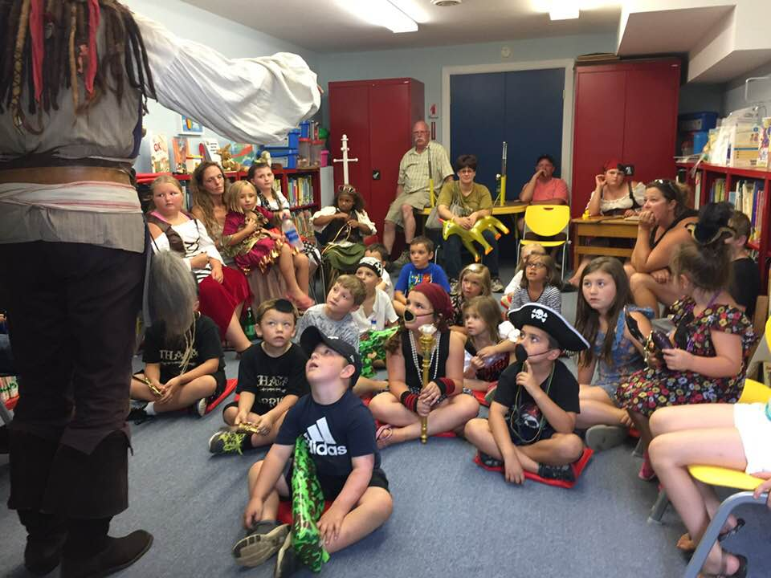

2019 was a very busy year at the Fair Haven Public Library here are some of the highlights of 2019 compared to the statistics of 2018

Patrons made **12,120** visits to the library this is an increase of **11.23%**

**6,676** items were circulated a **14.6 %** increase

**1,262** reference transactions a **1.6%** increase

We borrowed **1,061** items a **21.53 %** increase through Interlibrary loan.

We loaned **3,438** items a **15.29 %** increase through Interlibrary loan.

Computers were used **368** times for an increase of **26.8 %**

Wireless internet was used **2,920** times for a **33.3 %** increase in use.

**48,640** visits were made to our website this is a decrease of **.07%**

FAIR HAVEN PUBLIC LIBRARY

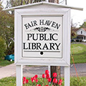

2019

ANNUAL REPORT

TO THE COMMUNITY

